Exercise-section27

Mehrab Atighi

12/22/2021

Data = data.frame(  
 Country = c("Albania" , "Austria" , "Belgium",  
 "Bulgaria" , "Czech" , "Denmark" ,  
 "E.Germany" , "Finlad" , "France",  
 "Greece" , "Hungary" , "Ireland" ,  
 "Italy" , "Netherlands" , "Norway" ,  
 "Poland" , "Portugal" , "Romania" ,  
 "Spain" , "Sweden" , "Switzerland" ,  
 "UK" , "USSR" , "W.Germany" , "Yogoslavia"),  
 Red_Meat = c(10.1,8.9,13.5,7.8,9.7,10.6,8.4,  
 9.5,18,10.2,5.3,13.9,9,9.5,9.4,  
 6.9,6.2,6.2,7.1,9.9,13.1,17.4,  
 9.3,11.4,4.4),  
 White_Meat = c(1.4,14,9.3,6,11.4,10.8,11.6,  
 4.9,9.9,3,12.4,10,5.1,13.6,  
 4.7,10.2,3.7,6.3,3.4,7.8,  
 10.1,5.7,4.6,12.5,5),  
 Eggs = c(0.5,4.3,4.1,1.6,2.8,3.7,3.7,2.7,  
 3.3,2.8,2.9,4.7,2.9,3.6,2.7,2.7,  
 1.1,1.5,3.1,3.5,3.1,4.7,2.1,4.1,  
 1.2),  
 Milk = c(8.9,19.9,17.5,8.3,12.5,25,11.1,  
 33.7,19.5,17.6,9.7,25.8,13.7,23.4,  
 23.3,19.3,4.9,11.1,8.6,24.7,23.8,  
 20.6,16.6,18.8,9.5),  
 Fish = c(0.2,2.1,4.5,1.2,2,9.9,5.4,5.8,5.7,  
 5.9,0.3,2.2,3.4,2.5,9.7,3,14.2,1,  
 7,7.5,2.3,4.3,3,3.4,0.6),  
 Cereals = c(42.3,28,26.6,56.7,34.3,21.9,  
 24.6,26.6,28.1,41.7,40.1,24,  
 36.8,22.4,23,36.1,27,49.6,29.2,  
 19.5,25.6,24.3,43.6,18.6,55.9),  
 Strachy_Foods = c(0.6,3.6,5.7,1.1,5,4.8,6.5,  
 5.1,4.8,2.2,4,6.2,2.1,4.2,  
 4.6,5.9,5.9,3.1,5.7,3.7,  
 2.8,4.7,6.4,5.2,3),  
 Nuts = c(5.5,1.3,2.1,3.7,1.1,0.7,0.8,1,2.4,  
 7.8,5.4,1.6,4.3,1.8,1.6,2,4.7,5.3,  
 5.9,1.4,2.4,3.4,3.4,1.5,5.7),  
 Fruit_veg = c(1.7,4.3,4,4.2,4,2.4,3.6,1.4,  
 6.5,6.5,4.2,2.9,6.7,3.7,2.7,  
 6.6,7.9,2.8,7.2,2,4.9,3.3,2.9,  
 3.8,3.2))  
rownames(Data) = Data[,1]  
Data[,1] = c()  
library(factoextra)

## Loading required package: ggplot2

## Welcome! Want to learn more? See two factoextra-related books at https://goo.gl/ve3WBa

library(gridExtra)  
model1 = kmeans(Data , 5 , 1000 , algorithm = "Hartigan-Wong")  
model2 = kmeans(Data , 5 , 1000 , algorithm = "Lloyd")  
model3 = kmeans(Data , 5 , 1000 , algorithm = "Forgy")  
model4 = kmeans(Data , 5 , 1000 , algorithm = "MacQueen")  
  
  
# plots to compare  
p1 <- fviz_cluster(model1, geom = "point", data = Data) + ggtitle("method = 1")  
p2 <- fviz_cluster(model2, geom = "point", data = Data) + ggtitle("method = 3")  
p3 <- fviz_cluster(model3, geom = "point", data = Data) + ggtitle("method = 4")  
p4 <- fviz_cluster(model4, geom = "point", data = Data) + ggtitle("method = 5")  
grid.arrange(p1, p2, p3, p4, nrow = 2)

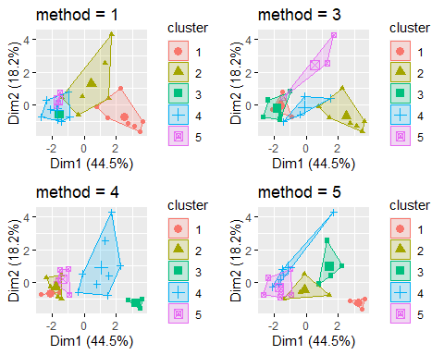

# B)  
  
  
Data2 = data.frame(  
 City = c("Atlanta" , "Boston" , "Chicago" ,  
 "Dallas" , "Denver" , "Detroit",  
 "Hartford" , "Honolulu" , "Houston",  
 "Kansas City" , "Los Angeles" ,  
 "New Orleans", "New York",  
 "Portland" , "Tucson" ,  
 "Washington"),  
 Murder = c(16.5,4.2,11.6,18.1,6.9,13.0,  
 2.5,3.6,16.8,10.8,9.7,10.3,  
 9.4,5.0,5.1,12.5),  
 Rape = c(24.8,13.3,24.7,34.2,41.5,35.7,  
 8.8,12.7,26.6,43.2,51.8,39.7,  
 19.4,23.0,22.9,27.6),  
 Robbery = c(106,122,340,184,173,477,  
 68,42,289,255,286,266,  
 522,157,85,524),  
 Assault = c(147,90,242,293,191,220,  
 103,28,186,226,355,283,  
 267,144,148,217),  
 Burglary = c(1112,982,808,1668,1534,  
 1566,1017,1457,1509,1494,  
 1902,1056,1674,1530,1206,  
 1496),  
 Larceny = c(905,669,609,901,1368,1183,  
 724,1102,787,955,1386,  
 1036,1392,1281,756,1003),  
 AutoThef = c(494,954,645,605,780,  
 788,468,637,697,765,862,  
 776,848,488,483,793))  
  
  
  
Data2 = Data2[1:6,]  
rownames(Data2) = Data2 [1:6 , 1]  
Data2[,1] = c()  
  
Dist1 = dist(Data2, method = "euclidean",diag = TRUE , upper = TRUE)  
  
#single method  
model1 = hclust(Dist1 , method = "single")  
model1

##   
## Call:  
## hclust(d = Dist1, method = "single")  
##   
## Cluster method : single   
## Distance : euclidean   
## Number of objects: 6

plot( model1 , hang = -1 )

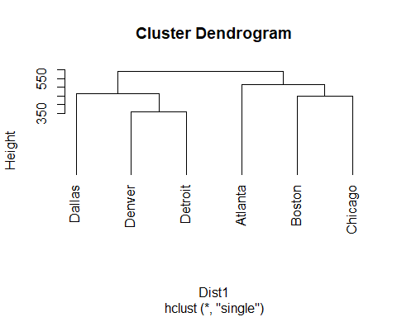

#complete method:  
model2 = hclust(Dist1 , method = "complete")  
model2

##   
## Call:  
## hclust(d = Dist1, method = "complete")  
##   
## Cluster method : complete   
## Distance : euclidean   
## Number of objects: 6

plot( model2 , hang = -1 )

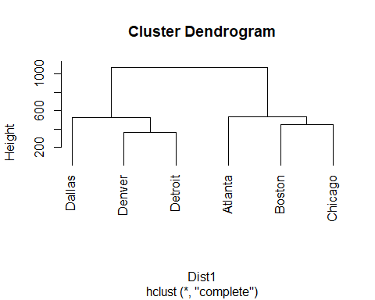

#average method:  
model3 = hclust(Dist1 , method = "average")  
model3

##   
## Call:  
## hclust(d = Dist1, method = "average")  
##   
## Cluster method : average   
## Distance : euclidean   
## Number of objects: 6

plot( model3 , hang = -1 )

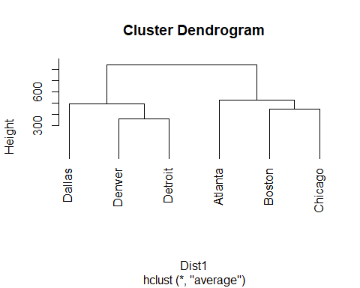

#ward method:  
model4 = hclust(Dist1 , method = "ward.D")  
model4

##   
## Call:  
## hclust(d = Dist1, method = "ward.D")  
##   
## Cluster method : ward.D   
## Distance : euclidean   
## Number of objects: 6

plot( model4 , hang = -1 )

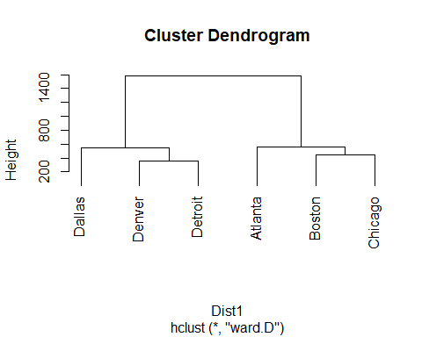

# Elbow Method :  
  
set.seed(123)  
# function to compute total within-cluster sum of square   
wss <- function(k) {  
 kmeans(Data2, k )$tot.withinss  
}  
  
# Compute and plot wss for k = 1 to k = 5  
k.values <- 1:5  
  
# extract wss for 2-15 clusters  
library(tidyverse)

## -- Attaching packages --------------------------------------- tidyverse 1.3.1 --

## v tibble 3.1.5 v dplyr 1.0.7  
## v tidyr 1.1.4 v stringr 1.4.0  
## v readr 2.1.1 v forcats 0.5.1  
## v purrr 0.3.4

## -- Conflicts ------------------------------------------ tidyverse_conflicts() --  
## x dplyr::combine() masks gridExtra::combine()  
## x dplyr::filter() masks stats::filter()  
## x dplyr::lag() masks stats::lag()

wss_values <- map_dbl(k.values, wss)  
  
plot(k.values, wss_values,  
 type="b", pch = 19, frame = FALSE,   
 xlab="Number of clusters K",  
 ylab="Total within-clusters sum of squares")

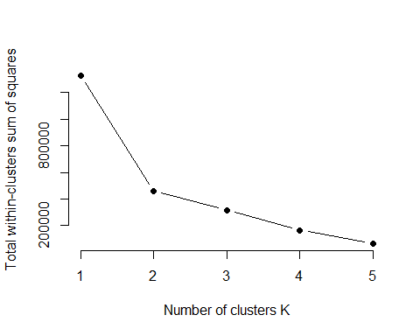

#fviz_nbclust(Data2, kmeans, method = "wss")  
  
  
  
####  
# function to compute average silhouette for k clusters  
library(cluster)  
avg_sil <- function(k) {  
 km.res <- kmeans(Data2, centers = k)  
 ss <- silhouette(km.res$cluster, dist(Data2))  
 mean(ss[, 3])  
}  
  
# Compute and plot wss for k = 2 to k = 15  
k.values <- 2:5  
  
# extract avg silhouette for 2-15 clusters  
avg_sil_values <- map_dbl(k.values, avg_sil)  
  
plot(k.values, avg_sil_values,  
 type = "b", pch = 19, frame = FALSE,   
 xlab = "Number of clusters K",  
 ylab = "Average Silhouettes")

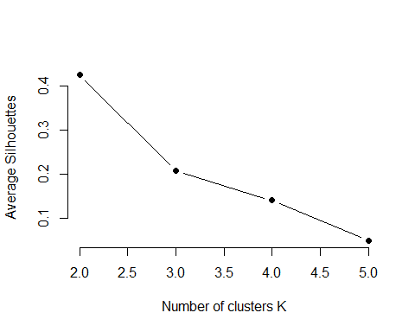

#fviz_nbclust(Data2, kmeans, method = "silhouette" )  
  
  
####  
  
# compute gap statistic  
  
#gap_stat <- clusGap(Data2, FUN = kmeans,  
 #K.max = 10, B = 50)  
# Print the result  
#print(gap_stat, method = "firstmax")  
  
#fviz_gap_stat(gap_stat)